Patterns of Adopting Change

Pathways of Innovation

“Innovation moves through the system by tolerance to risk”
Rodgers , Moore 1993

Changing Behaviour
the adoption curve

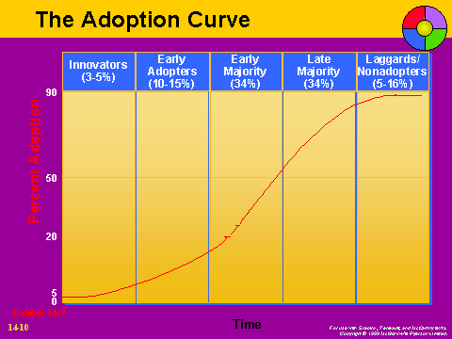
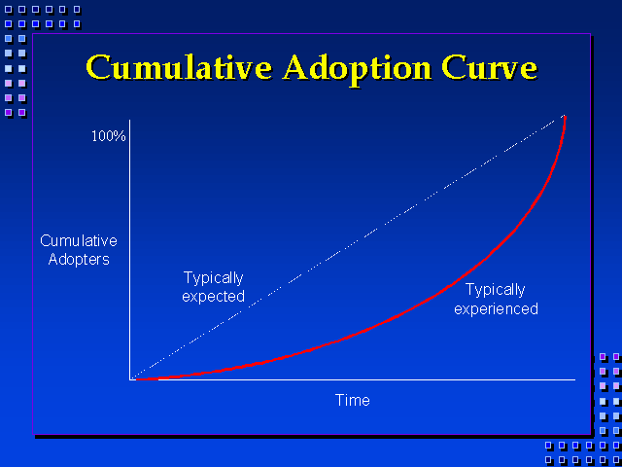

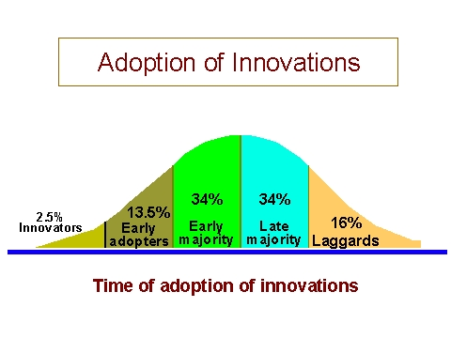

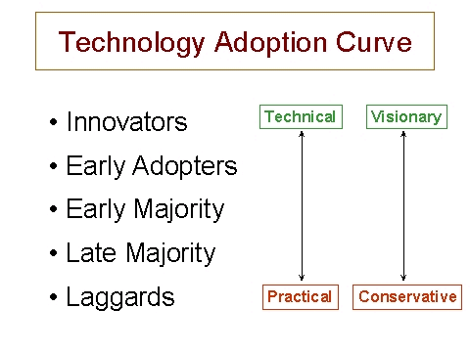
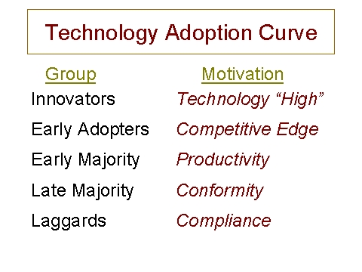

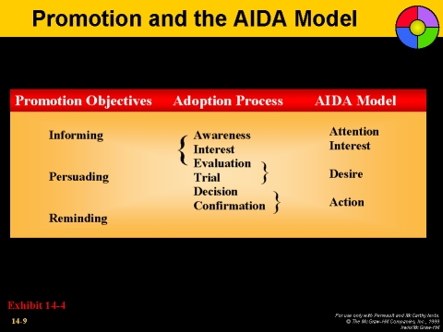

A special kind of diffusion is the adoption of innovations. To adopt an innovation means to acquire a new product or behavior. For example, it used to be that in America people believed that tomatoes were poisonous and wouldn’t eat them. Eventually, though, through immigrants, people started eating them. Similarly, people all over the world are buying personal computers, something that essentially did not exist before the 1980s.

This is consistent with a network effect where one doctor persuades his friends, who then persuade their friends, etc. which creates an exponential growth process.

